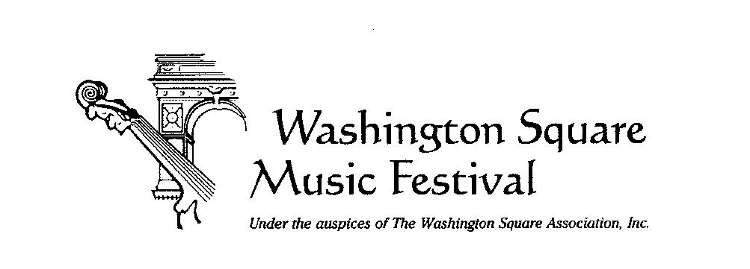

**Contact: Peggy Friedman 917-855-4205**

**WASHINGTON SQUARE MUSIC FESTIVAL RINGS IN THE HOLIDAYS**

**on Sunday, Dec. 8th, 4 pm**

The Washington Square Music Festival Rings in the Holidays and wraps up its 66th season on Sunday, December 8 at 4 pm in St. Mark’s Church-in-the-Bowery. Music Director Ahmed Alom conducts the Festival Chamber Orchestra in works spanning four centuries of creativity. Mezzo-Soprano Rosario Armas is featured in the Schumann, Mahler, and de La Chica works. The concert is free; seating is first come, first served.

**WASHINGTON SQUARE MUSIC FESTIVAL**

**Sunday, December 8, 2024, 4 pm FREE**

St. Mark’s Church-in-the-Bowery

131 East 10th Street

New York NY 10003

ws-mf.org

**The Festival Chamber Orchestra**

[**Ahmed Alom**](https://www.ahmedalom.com/)**, conductor**

[**Rosario Armas**](https://rosarioarmas.com/)**, mezzo-soprano**

**Claude Debussy: Prélude à l'après-midi d'un faune**

**Clara Schumann: Lieder op. 12**

**Gustav Mahler: Lieder eines fahrenden Gesellen (“Songs of a Wayfarer”)**

**[Julian De La Chica](https://juliandelachica.com/): Canciones de la Muerte op. 20 (premiere)**

**J. S. Bach: Brandenburg Concerto no. 5 in D major**

Praised by his technical command, musicality and great versatility, **conductor**, **pianist, and composer** **Ahmed Alom** is one of the leading young artists in New York City, having performed with Louisville Symphony Orchestra, New World Symphony Orchestra, Orquesta Filarmónica de Mexico, and Britt Festival Orchestra. 2024 marks his first season as Music Director of the Washington Square Music Festival.

A prize winner of the New York Young Musicians Competition, Slatkin Competition at Manhattan School of Music, Maria Clara Cullell Competition (Costa Rica), and the National Chamber Music Competition (Mexico), he was a finalist of the 66th New York Chopin Competition by Kosciuszko Foundation, and the recipient of the Munz Foundation Scholarship for Young Artists.

As a conductor, he has led the Ballet Hispanico Ensemble, and the Association of Dominican Classical Artists in New York. Mr. Alom has performed as a soloist with orchestras in Spain, Cuba, Mexico, and the United States, performing works ranging from Beethoven to Chopin, Gershwin, and contemporary composers.

As a jazz and Latin jazz pianist, he has appeared in festivals in the US, Canada, Mexico, Spain, Costa Rica and Cuba. He has performed at Jazz at Lincoln Center, Montreal Jazz Festival, Rochester Jazz Festival, Newport Jazz Festival,  the Manhattan School of Music Afro Cuban Jazz Band, ExitZero Jazz Festival and Jazz Night in America. He has also arranged and written music for Pedrito Martinez Group, Canadian Brass, and People of Earth.

He has collaborated on several studio albums: “Impulso Tanguero” with the Pedro Giraudo Tango Quartet, “And I Love Her” with Steve Hackman, “Doña Peron” by Peter Salem, and with Grammy Winner bandoneonist Hector del Curto among others.

**Mexican Mezzo-Soprano, Rosario Armas,** is considered a “unique colorful performer” by critics in Mexico and USA. Her mastery of the upper and lower vocal ranges allows her to sing roles such as Rosina, Angelina, Sesto and Carmen. Her performances include Cherubino in Le nozze di Figaro, Flora in La traviata, Dorabella in Cosi fan tutte, Orfeo in Orfeo ed Euridice, Masha from Cheryomushki and Juana from la Opera Juana in Mexico, Europe, and the United States. This marks her debut with the Washington Square Music Festival.

Ms. Armas has also sung several recitals at Teatro Xicotencatl, Teatro Pablo Villa Vicencio, and La Casa de Musica de Viena in Mexico as well as Teatros di Santarcangelo, Santa Agata Feltria and Novafeltria from the province of Emilia-Romagna in Italy. She received the Judith Raskin Scholarship from 2018 to 2022, and the International Advisory Board Scholarship from 2021 to 2022. Ms. Armas was awarded 1st prize in the Eisenberg-Fried Competition 3rd place in the Ades Competition, and the Encouragement award at the MONC auditions in 2020 and 2021.

Praised for his "meditative simplicity" [*The New Yorker*], described as "an extraordinarily deep thinker... able to take a listener into mysterious byways using very slender means" [Music Trust], and noted for his "spare and pensive" music [*NewSounds***]**, **composer** **Julián De La Chica** is an award-winning Colombian multidisciplinary artist and author (AWA), based in Brooklyn, NY. His influences range from minimalism and post-minimalism to the alternative electronic scene. His work often juxtaposes spiritual reflection with an exploration of humanity’s inner darkness, drawing inspiration from everyday images. His music mixes piano, strings, and classical voices with electronic keyboards and controllers, crossing genres from classical to ambient and electronic music. With a discography that includes six solo albums and over eighteen collaborative projects (between singles and albums), De La Chica’s music has been recorded and performed by artists worldwide and has been featured on Spotify’s *Classical New Releases* playlist.

The Washington Square Music Festival is made possible with public funding from the New York City Department of Cultural Affairs and Councilmember Christopher Marte, and the New York State Council on the Arts with the support of Governor Kathy Hochul and the New York State Legislature. Generous grants from The Earle K. & Katherine F. Moore Foundation, The Washington Square Association, The Margaret Neubart Foundation Trust, New York University Community Affairs & NYU Community Fund, the Salamon-Abrams Family Fund, and the Washington Square Park Conservancy are deeply appreciated.